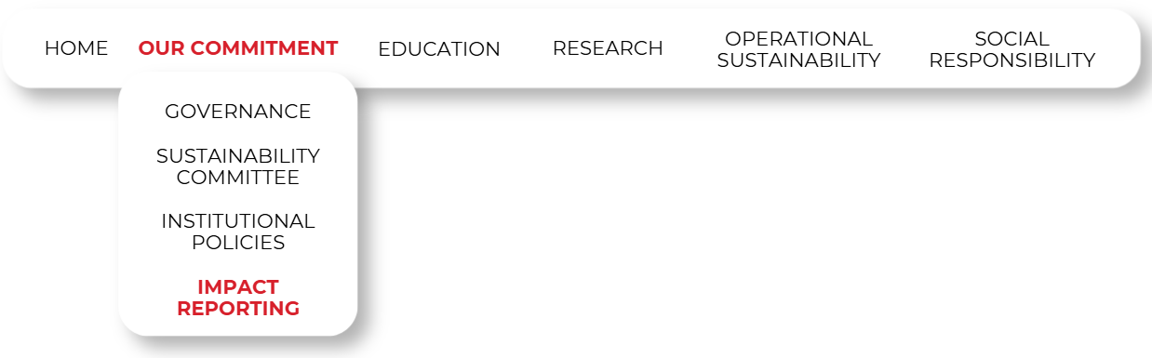
UN PRME Reports
CUD is a proud partner of the United Nations Principles for Responsible Management Education (UN PRME), committed to sustainability, ethics, and social responsibility; aiming to empower a generation of change-makers. Together with UN PRME, CUD is shaping the future of business and management education. Read the reports below:
2023  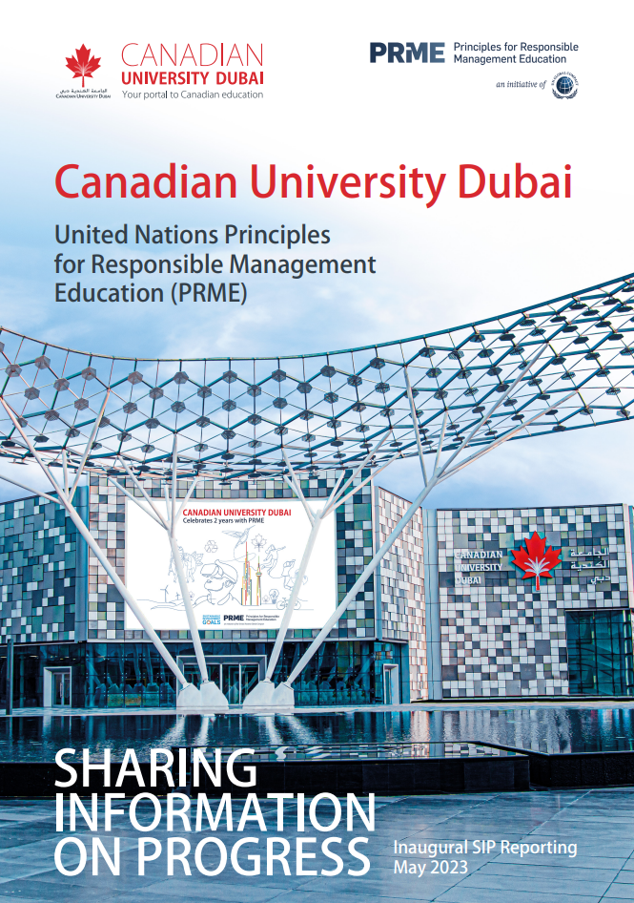 | 2025  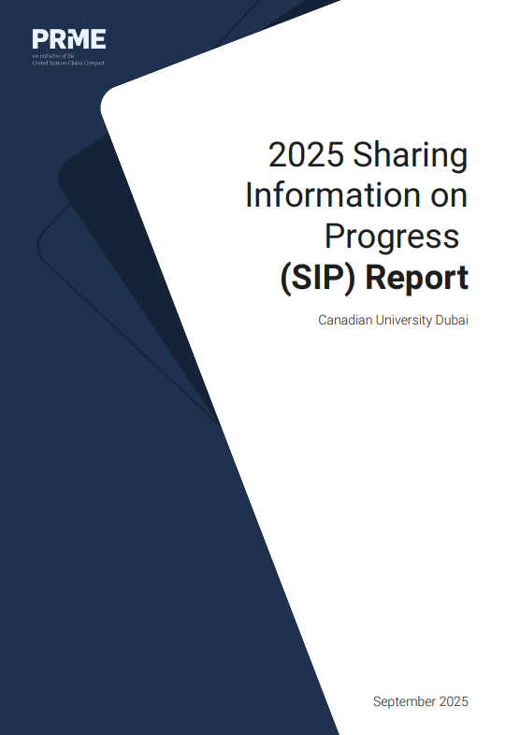
CUD Facilities Carbon Performance and Sustainability Roadmap: 2026
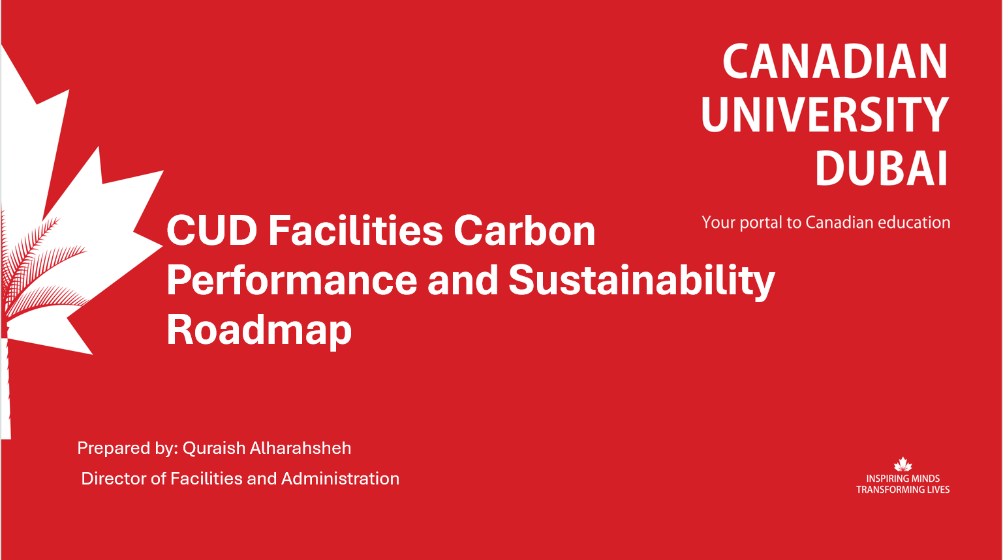

CUD Publications on UN SDGs
SDG | Number of Publications | SDG | Number of Publications
Goal 1: No poverty | 16 | Goal 10: Reduced inequalities | 51
Goal 2: Zero hunger | 9 | Goal 11: Sustainable cities and communities | 40
Goal 3: Good health and well-being | 112 | Goal 12: Responsible consumption and production | 112
Goal 4: Quality education | 73 | Goal 13: Climate action | 55
Goal 5: Gender equality | 24 | Goal 14: Life below water | 2
Goal 6: Clean water and sanitation | 12 | Goal 15: Life on land | 17
Goal 7: Affordable and clean energy | 74 | Goal 16: Peace, justice and strong institutions | 44
Goal 8: Decent work and economic growth | 124 | Goal 17: Partnership for the goals | 91
Goal 9: Industry, innovation and infrastructure | 155

View the full list of Scopus (login required)

